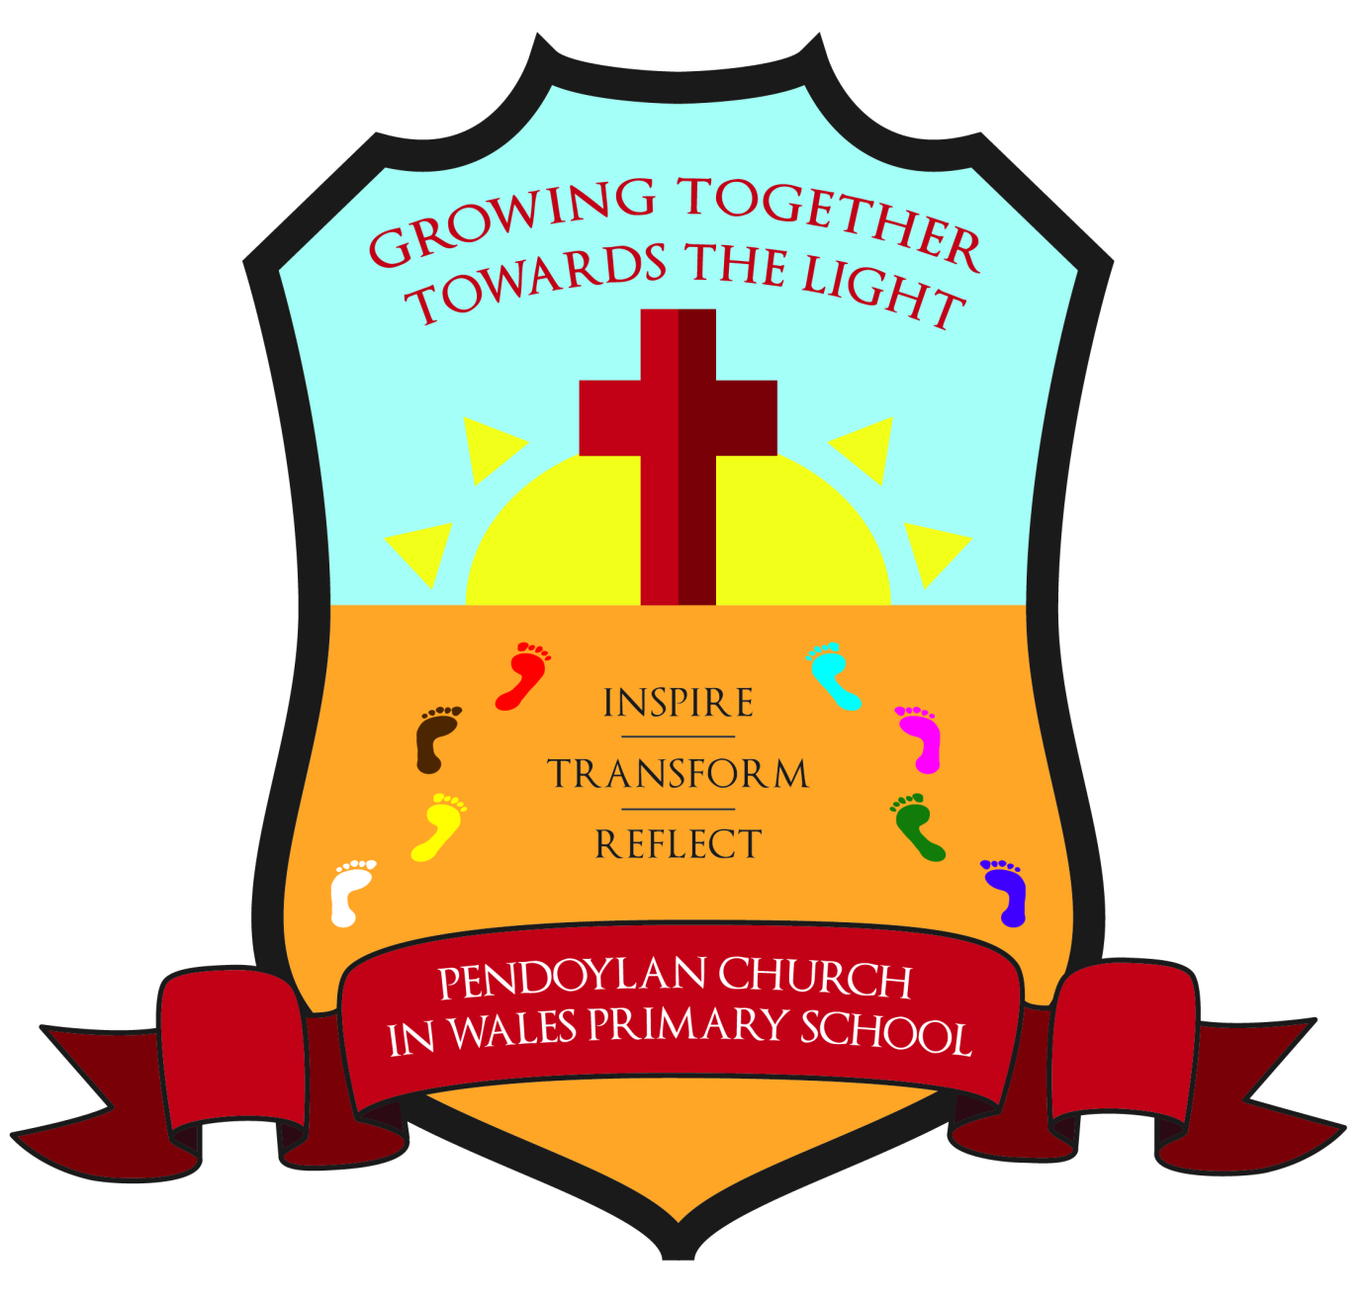

Pendoylan Church in Wales
RVE Policy

Date approved by Governing Body: March 2026

Signed by Chair of Governors:

Signed by Headteacher:

Date of Next Review (max 3 years): Spring 2028

Religion, Values and Ethics policy

Religion, values and ethics (RVE) at Pendoylan Church in Wales Primary School forms part of the Humanities area of learning. Religion, values and ethics is a statutory requirement of the Curriculum for Wales and is mandatory for all learners from ages 3 to 16. There is no parental right to request that a child is withdrawn from RVE.
As a voluntary aided school, we follow the Church in Wales guidance Designing your Curriculum Guidance - The Church in Wales whilst also having regard for the Vale of Glamorgan Agreed Syllabus. This policy meets the requirements of the Curriculum and Assessment Act (Wales) 2021

RVE in Pendoylan Church in Wales Primary School will:
Reflect the fact that the religious traditions in Wales are in the main Christian while taking account of the teaching and practices of the other principal religions represented in Wales.
Also reflect the fact that a range of non-religious philosophical convictions are held in Wales. (Schedule 2 Curriculum and Assessment Act (Wales) 2021)
All our learners will be offered opportunities through RVE to engage with different religions and non-religious philosophical convictions in their own locality and in Wales, as well as in the wider world.

Religion, Values and Ethics (RVE) within the Curriculum for Wales will offer our learners a distinctive contribution to the realisation of the four purposes. RVE prepares our learners in Wales for life and work in a fast-changing and diverse world, as responsible and informed citizens. RVE is a mandatory element of our curriculum and as such is provided for all our learners as a basic entitlement.

RVE sits within the Humanities Area and incorporates a range of disciplinary approaches that will be used by our learners to engage critically with a broad range of religious and non-religious concepts. We will draw on a variety of approaches such as:

Religious studies
Philosophy
Theology
Sociology
Psychology
Anthropology
Our school will provide strong relationships between RVE and other disciplines within Humanities (such as history and geography), as well as with other Areas in the Curriculum for Wales.

We aim to:

Provide rich contexts for learners to be curious, to explore ultimate questions and to search for an understanding of the human condition, as well as providing opportunities for learners to reflect and to experience awe and wonder, in a range of meaningful real-world contexts.
Develop rich contexts for enquiry into the concepts of religion, lived religion, worldviews, secularity, spirituality, life stance, identity and culture to develop learners’ well-rounded understanding of religious and non-religious beliefs and practices.
Provide rich contexts for engaging with concepts of belief, faith, truth, purpose, meaning, knowledge, sources of authority, self, origin, life, death and ultimate reality, which can enable learners to develop an understanding of personal and institutional beliefs about the nature of life and the world around them.
Develop rich contexts for exploring the concepts of identity, belonging, relationships, community, cynefin, diversity, pluralism and interconnectedness, which can enable learners to gain a sense of self and develop spirituality.
Explore the concepts of equality, sustainability, tolerance, freedom, prejudice, discrimination, extremism, good and evil, which can give learners an insight into the challenges and opportunities that face societies.
Reflect the concepts and contexts of religiosity, practice, ritual, tradition, worship, sacredness, symbolism and celebration to develop learners’ understanding of religion and belief.
Provide rich contexts for exploring the concepts of ethics, morality, justice, responsibilities, authority, humanity, rights, values and social action.
As a [School Type], we will include the following key concepts of Christianity within our RVE curriculum:

God, Trinity
Creation
Fall
Incarnation
Salvation
The Kingdom of God/The Gospels/Life and Teachings of Jesus
Sacred Texts/The Bible
Expressions of Faith
Identity
Commitment
Community/Worship
Equality and Justice
Many of the above concepts/areas of study will provide a starting point for wider discussion and comparison with other religions and non-religious beliefs and practices.

RVE will be objective, critical and pluralistic, both in content and pedagogy, in line with the European Conventions of Human Rights.

Our teaching of RVE will promote openness, impartiality and respect for others.

RVE at [School Name] contributes to the cross-cutting themes in the Curriculum for Wales in rich and meaningful ways. These include:

Literacy, numeracy and digital competence
The skills integral to the four purposes, which aspire for all learners to be:
Ambitious, capable learners, ready to learn throughout their lives
Enterprising, creative contributors, ready to play a full part in life and work
Ethical, informed citizens of Wales and the world
Healthy, confident individuals, ready to lead fulfilling lives as valued members of society
Consideration of local, national and international contexts
Develop understanding of relationships and sexuality education, human rights education and diversity, and careers and work-related experiences
RVE also contributes to the spiritual development of learners in our school. We will provide opportunities for learners to:

Have an awareness of themselves in relation to others
Make connections to the wider and the natural world
Develop creativity, experience awe and wonder and foster curiosity
Explore ultimate questions and contemplate the meaning and purpose of life.
We will also provide opportunities for spiritual development as we engage with our ‘cynefin’ and experiences that occur in everyday life within our local, national and global communities.

We define Cynefin as ‘The place where we feel we belong, where the people and landscape around us are familiar, and the sights and sounds are reassuringly recognisable. Though often translates as 'habitat' cynefin is not just a place in a physical or geographical sense: it is the historic, cultural and social place which has shaped and continues to shape the community which inhabits it.’ (Curriculum for Wales)

To ensure that our curriculum provides a broad understanding of RVE, we have designed our provision around the five Humanities: Statements of what matters - Hwb (gov.wales). Our provision has also been designed using the 7 RVE sub lenses included in the [Local Authority] Agreed Syllabus for RVE and the statutory Religion, Values and Ethics guidance on Hwb.

The RVE sub lenses are:

Search for meaning and purpose. How people respond to the deeper questions of life in order to understand the human condition.
The natural world and living things. How and why people show concern and responsibility for the world and experience awe and wonder in nature.
Identity and belonging. What makes us who we are as people, communities and citizens living in a diverse world.
Authority and influence. How and why different types of authority influence people’s lives.
Relationships and responsibility. How people live together and why developing healthy relationships is important.
Values and ethics. How and why people make moral choices and how this influences their actions.
The journey of life. What people experience as part of the journey of life and how these experiences are acknowledged.
These sub lenses help us to provide appropriate breadth and depth in RVE, and it is through these sub lenses that concepts can be viewed and explored. At [School Name] we aim to ensure that over a learner’s journey from age 3 to 11, a wide variety of concepts will have been explored through these different lenses as part of our RVE provision.

Our curriculum is supported by effective teaching and learning that enables learners to make meaningful progress in RVE. We implement the five principles of progression from the curriculum for Wales to do this.

The five principles of progression are:

Increasing effectiveness as a learner
Increasing breadth and depth of knowledge
Deepening understanding of the ideas and disciplines within Areas
Refinement and growing sophistication in the use and application of skills
Making connections and transferring learning into new contexts
Our school mission statement ‘Dream, Aspire and Achieve together in Love and Faith’ was revised in 2019 to reflect our [School Type] status. This was done, in collaboration with all stakeholders, including Governors, parents, staff and children. Our mission statement aims to reflect the importance of both the Christian ethos and values, at the heart of our school.

We will build upon the tradition in [School Name] of working thematically across the areas of learning, using a range of strategies and opportunities to plan exciting, creative and equitable learning opportunities both indoors and outdoors.

Pupil voice is at the heart of each classroom and pupils are able to develop and influence their learning in a way that best suits them. We hope to nurture young people who are:

Confident to try new things, to embrace challenges, share questions and ideas.
Enthusiastic to participate, be positive and encourage others.
Focused to stay on task, contribute to learning and not distract others from learning.
Creative to use their own ideas and find solutions to problems.
Dependable to be relied on and to do what is expected and help others.
Curious to be motivated to learn, to explore and experiment, and ask questions.
Empathetic to understand their own feelings and those of their peers, to recognise that their actions have consequences and to own their mistakes.
Resilient to persevere, to accept that mistakes are a valuable part of learning, to try different ways to solve problems.
Keen to work hard to achieve their targets, to always try their best, to challenge themselves and seek challenge to improve. To use their initiative and be responsible for their learning.

