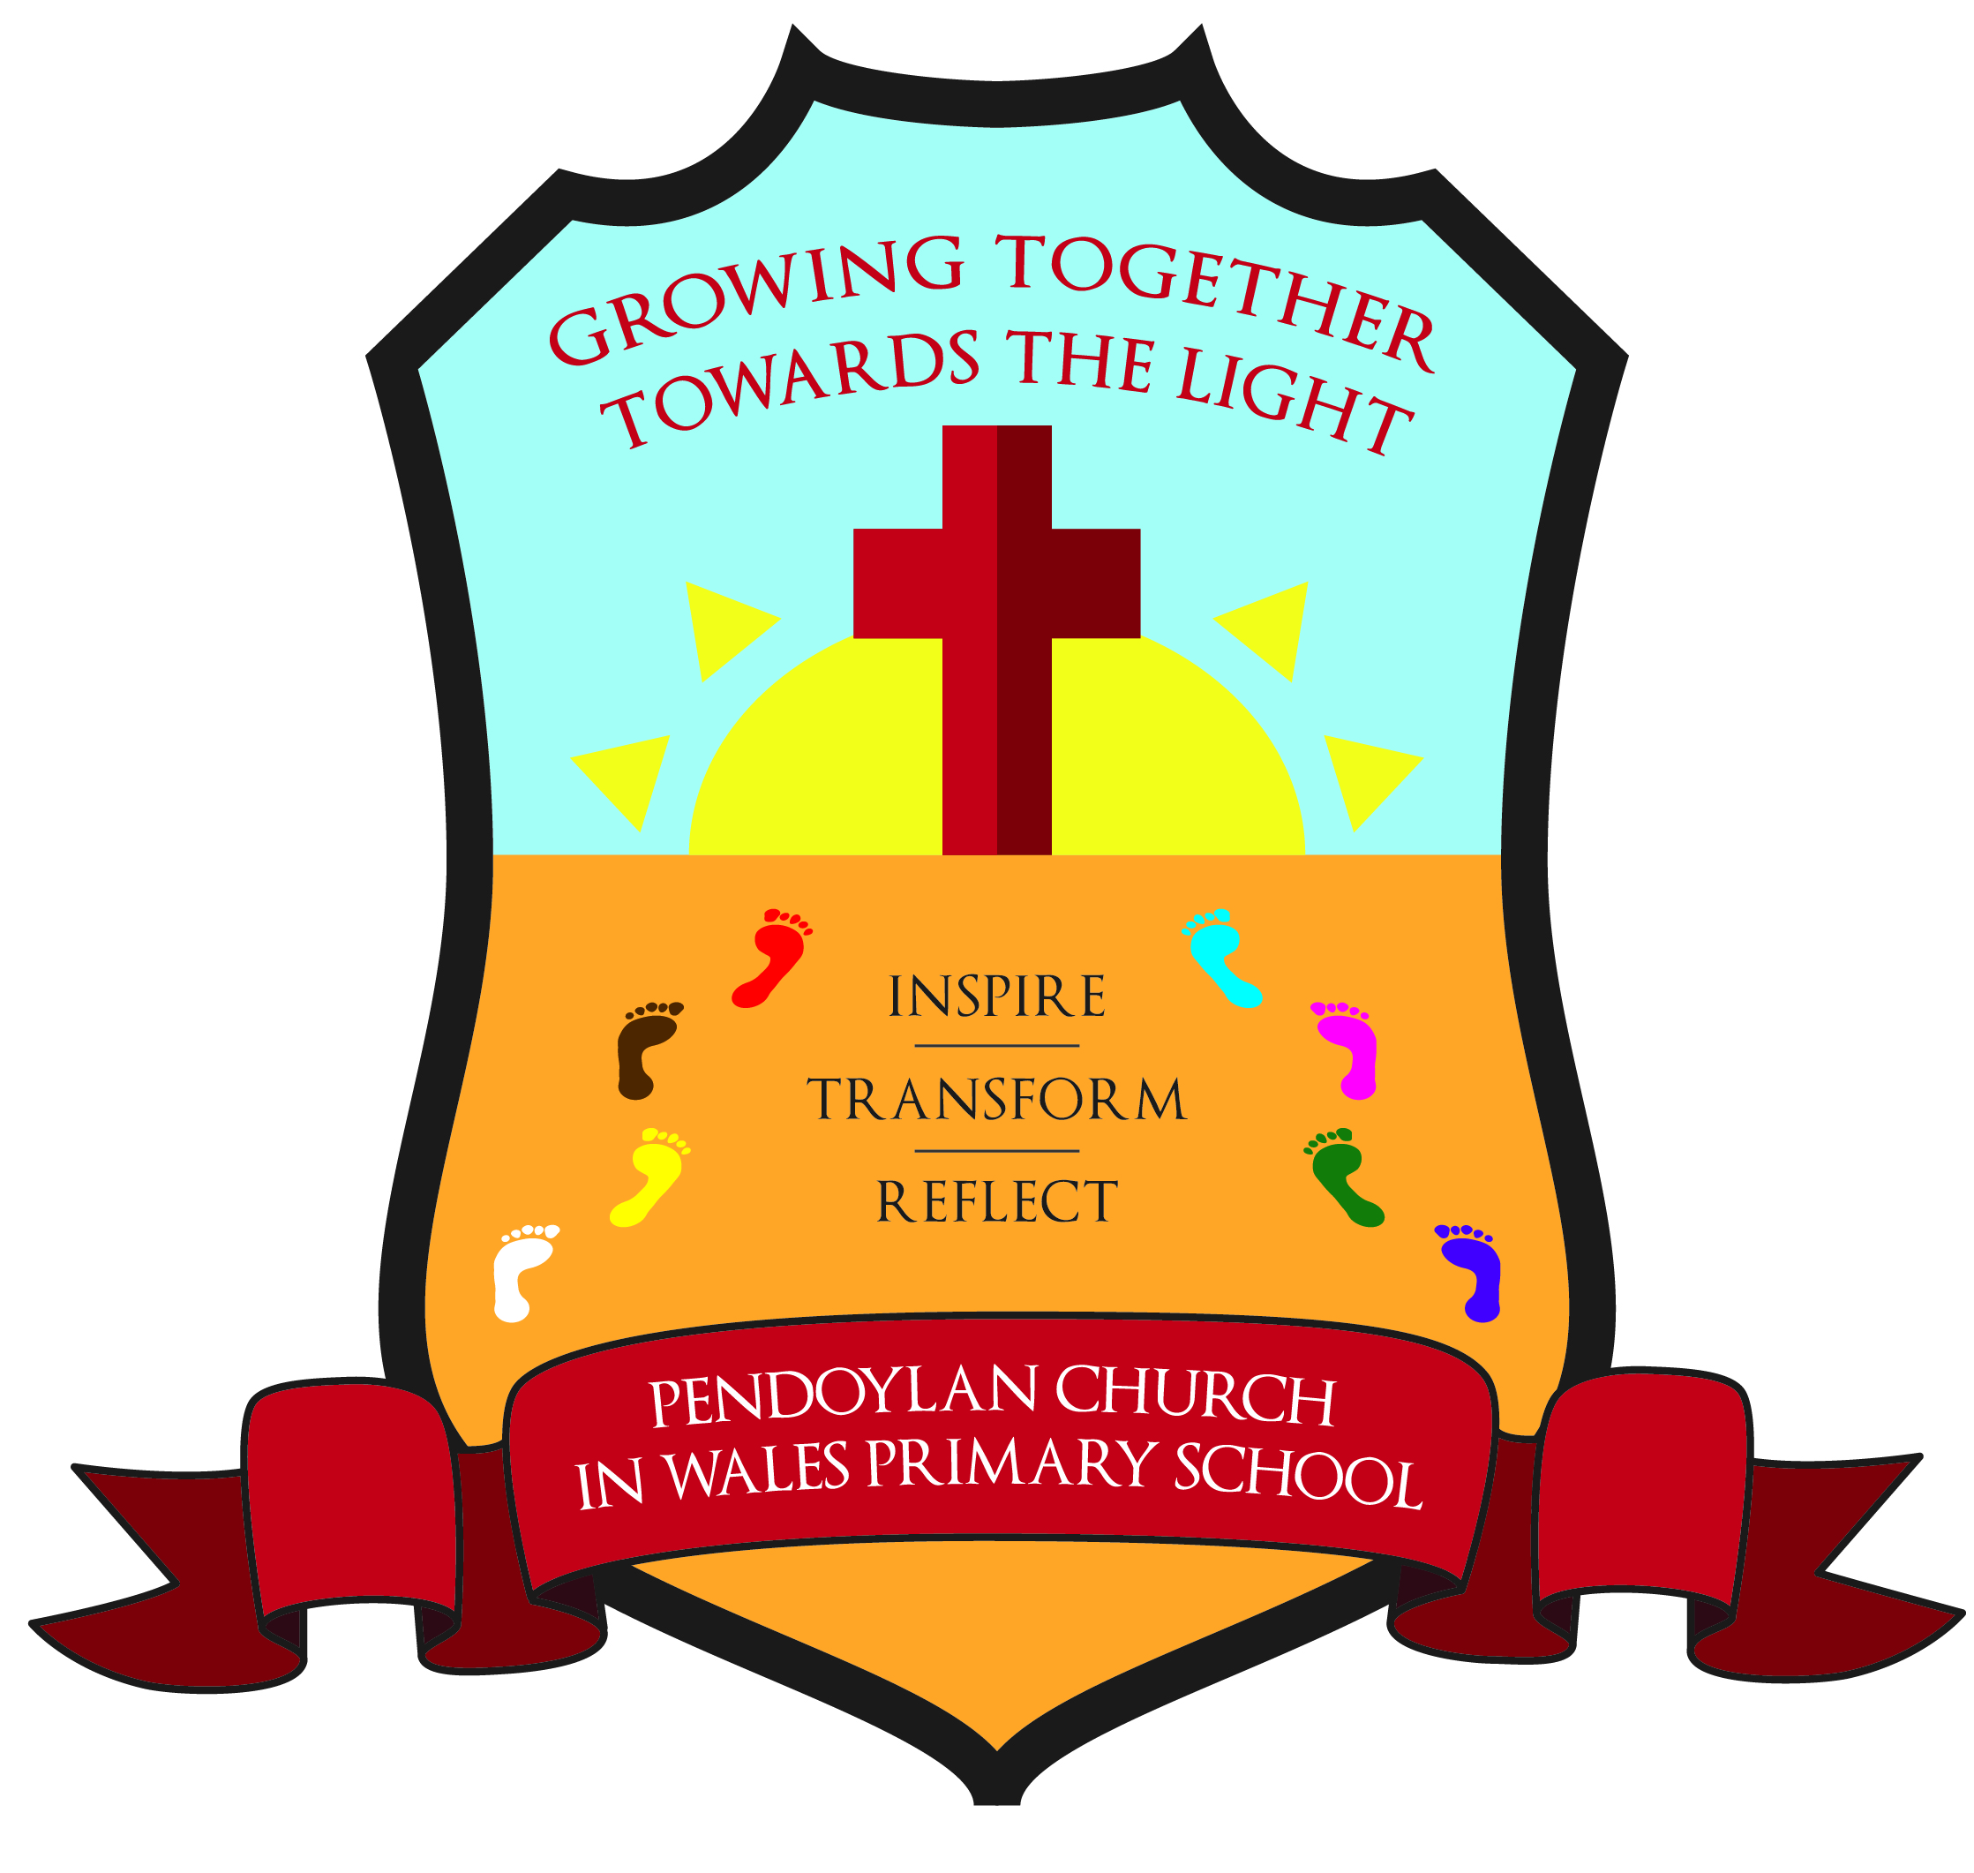
Pendoylan Church in Wales Primary School

Policy on Education for Sustainable Development and Global Citizenship (ESDGC)

1 Aims and objectives
1.1 Introduction

Education for sustainable development and global citizenship is:

- the links between society, economy and environment and between our own lives and those of people throughout the world

- the needs and rights of both present and future generations

- the relationships between power, resources and human right

- the local and global implications of everything we do and the actions that individuals and organisations can take in response to local and global issues

Aims

At Pendoylan Church in Wales Primary School our aims are to:

- Enable pupils to learn how to care for and protect their environment. We strive to reduce pollution, and use our natural resources with thought and care. We do this with the understanding that collectively, schools in Wales, the UK and globally, can make a huge difference.

- Help pupils to understand their own rights and responsibilities, as citizens locally and globally, and have respect for the rights and responsibilities of others. We strive to give them knowledge and understanding about our world and the people who live in it and to understand everyone’s relationship with the environment.

- Help them to develop the skills to be critical thinkers by giving them the facts. They are given a variety of resources so that they can have balanced information and come to their own judgments.

- Celebrate cultural, religious and linguistic diversity and foster positive attitudes towards others who are different to us.

- If it is to succeed, ESDGC needs to be addressed by the whole school community, not just teachers and learners, but parents,carers, governors, visitors and non-teaching staff. To be effective. ESDGC needs to be embedded across the curriculum and infused throughout the life of the school.

1.2 Our objectives in the teaching of ESDGC are:
- Wealth and Poverty

To enable the children to recognise that people should be entitled to have their basic needs met and to understand the effects of inequality on the quality of people’s lives. Local actions have effects in the wider world because of the connections between places and people.

- Identity and culture

To enable the children to: recognise the impact of discrimination and prejudice on individuals and groups. Recognise they are global citizens of an interconnected world and to understand we all have similarities and differences that people have differing beliefs and values cultural values and religious beliefs shape the way people live.

- Choices and decisions

To enable children to: participate in aspects of school life helping to make decisions. Express and enact respect for self and others, appreciate that personal actions have consequences. Question statements and opinions and look for evidence and to understand: how to prevent and avoid conflicts, what is meant by the rights of the child and that not everyone has these, that environment can be affected by the decisions we make individually and collectively

- Health

To enable the children to: care for their own health and the health of others, recognise their responsibilities to keep themselves and others safe. Appreciate the importance of family and community when making health choices and to understand the basic ingredients of a healthy lifestyle the impacts of environment on health and wellbeing, poverty and inequality cause health problems and vice versa, the importance of access to clean water for health.

- Natural environment

- To enable children to: develop respect for landscapes, habitats and living things. Develop a fascination with and respect for the natural world and to understand: the needs of living things, people depend on the environment for energy, food and other materials and resources.

- Consumption and waste

- To enable the children to: take personal action and influence others to save energy and reduce consumption. To understand: where the things people consume come from and go to, ways to reduce their energy use and the energy use of others. That waste can cause pollution.

- Climate change

- To enable the children to: to recognise that individuals and groups can take action to educate and campaign. That there is a range of views as to how best combat climate change and to understand: climate can change with time, the range of ways to both save and generate energy, the difference between climate and weather.

- To enable children to know and understand environmental problems at a local, regional and global level;
- To encourage in children a commitment to sustainable development, and an appreciation of what ‘global citizenship’ means;
- To develop in children a variety of other skills, including those of enquiry, problem-solving, ICT, investigation, and that of presenting their conclusions in the most appropriate way to develop the cross-curricular use of ESDGC in all subjects.

2 Teaching and learning style
2.1 We use a variety of teaching and learning styles in our ESDGC lessons. We believe in whole-class teaching as well as group collaborative methods, and we combine these with enquiry-based research activities. We encourage children to ask as well as answer ESDGC questions. We offer them the opportunity to use a variety of data, such as maps, statistics, graphs, pictures and aerial photographs, and we enable them to use ICT in ESDGC lessons where this serves to enhance their learning. Children take part in role-play and discussions, and they present reports to the rest of the class. They engage in a wide variety of problem-solving activities. Wherever possible, we involve the children in ‘real’ ESDGC activities, e.g. research of water consumption in the school.
2.2 We recognise the fact that there are children of widely different geographical abilities in all classes, and we provide suitable learning opportunities for all children by matching the challenge of the task to the ability of the child. We achieve this by:
- setting tasks which are open-ended and can have a variety of responses;
- setting tasks of increasing difficulty, some children not completing all tasks;
- grouping children by ability in the room, and setting different tasks to each ability group;
- providing resources of different complexity, according to the ability of the child;
- using classroom assistants to support the work of individual children or groups of children.

2.3 We endorse the curriculum aspirations set out in the ‘Successful Futures’ document, which is an independent review of the curriculum conducted by Professor Graham Donaldson and seek the highest standards of attainment for all our children.
Professor Donaldson points out that there are four main purposes of the curriculum, to develop children as –
- ambitious, capable learners ready to learn throughout their lives:
- enterprising, creative contributors, ready to play a full part in life and work
- ethical, informed citizens of Wales and the World
- healthy, confident individuals, ready to lead fulfilling lives as valued members of society.

3 ESDGC curriculum planning
3.1 We address the explicit references to sustainable development and global citizenship where they exist in the National Curriculum Programmes of Study through Key Skills and Essential Elements. Maximum opportunity will be taken to exploit specific local, national or global events e.g. tsunami, anniversaries of world events.

ESDGC is delivered through many areas of the curriculum such as PSE, ESDGC, Science and R.E. Teachers follow the National Curriculum Programmes of Study and identify the Key Skills and Essential Elements within those areas.
3.2 Our curriculum planning is in three phases (long-term, medium-term and short-term). Our long-term plan maps the ESDGC topics studied in each topic during each key stage. The subject leader devises this plan in conjunction with teaching colleagues in each year group. In other cases, we arrange for the children to carry out an independent ESDGC study.
3.3 We use the national schemes of work for PSE, ESDGC, Science and R.E. as the basis for our medium-term plans. This gives details of each unit of work to be covered in a year. The subject leader reviews these plans on a regular basis.
3.4 Each class teacher creates a plan for each lesson. These plans list specific learning objectives and expected outcomes for each lesson. The class teacher keeps these individual plans, and often discusses them with the ESDGC subject leader on an informal basis. The ESDGC subject leader also produces individual plans.
3.5 We plan the topics in ESDGC so that they build on prior learning. Children of all abilities have the opportunity to develop their skills and knowledge in each unit and, through planned progression built into the scheme of work, we offer them an increasing challenge as they move up the school.

4 The contribution of ESDGC to teaching in other curriculum areas
4.1 English
ESDGC makes a significant contribution to the teaching of English in our school because it actively promotes the skills of reading, writing, speaking and listening. We ensure that some of the texts that we use in the literacy hour are ESDGC in nature. At Key Stage 2, we organise debates on environmental issues, because we believe that these develop speaking and listening skills. Reports, letters and recording information will all develop children’s writing ability. We also use environmental issues as a way of developing the children’s writing ability, by asking them to record information and write reports and letters.
4.2 Mathematics
The teaching of ESDGC in our school contributes to children’s mathematical understanding in a variety of ways. We teach the children how to collect data and represent data. They also use graphs to explore, analyse and illustrate a variety of data.
4.3 Personal, social and health education (PSHE) and citizenship
ESDGC contributes significantly to the teaching of personal, social and health education and citizenship. Firstly, the subject matter lends itself to raising matters of citizenship and social welfare. For example, children study the way in which people recycle material, and how environments are changed for better or for worse. Secondly, the nature of the subject means that children have the opportunity to take part in debates and discussions. We allow them to organise campaigns on matters of concern to them, such as helping poor or homeless people. Thus, ESDGC in our school promotes the concept of positive citizenship.
4.4 Spiritual, moral, social and cultural development
We offer children in our school many opportunities to examine the fundamental questions in life through the medium of ESDGC. For example, their work on poverty of children. We encourage the children to reflect on the impact of mankind on our world, and we introduce the concept of ‘stewardship’ in relation to sustainable development. Through teaching about contrasting localities, we enable the children to learn about inequality and injustice in the world. We help children to develop their knowledge and understanding of different cultures, so that they learn to avoid stereotyping other people, and acquire a positive attitude towards others. We help contribute to the children’s social development by teaching them about how society works to resolve difficult issues of economic development. ESDGC contributes to the children’s appreciation of what is right and wrong by raising many moral questions during the programme of study.

Literacy and Numeracy Framework. Numeracy across the Curriculum.

5.1 The LNF is first and foremost a curriculum planning tool that supports all teachers in embedding literacy and numeracy across the curriculum and developing the literacy and numeracy skills of learners. At Pendoylan, the LNF is at the heart of curriculum planning. The LNF focuses on the learners’ acquisition of, and ability to apply, the skills and concepts they have learned to complete tasks appropriate for their stage of development. These enriched tasks are designed with a specific skill focus. They are designed to be progressive and differentiated. Enriched tasks are planned, across the curriculum, to be broad problem solving activities that allow pupils to practise and demonstrate a number of elements/aspects within the same task. The LNF is inclusive of all learners, including ALN and MAT pupils.

6 ESDGC and ICT
6.1 Information and communication technology enhances our teaching of ESDGC, wherever appropriate, in each key stage. This more than meets the statutory requirement for children to use ICT/DCF as part of their ESDGC work in Foundation Phase and KS2. Children use ICT to enhance their skills in data handling (climate, population) and in presenting written work. They research information through the Internet, libraries of digital images (data on climate change). We also arrange for the children to communicate with pupils in other schools and countries via e-mail, and we offer children the opportunity to use the digital cameras and IPads. Resources such as Google earth are used by the children when studying a locality.
6.2 Digital Competency Framework
From September 2016, Digital competence is one of 3 cross-curricular responsibilities, alongside literacy and numeracy. It focuses on developing digital skills which can be applied to a wide range of subjects and scenarios. The Framework, which has been developed by practitioners from Pioneer Schools, supported by external experts, has 4 strands of equal importance, each with a number of elements.
Citizenship – which includes:
- Identity, image and reputation
- Health and well-being
- Digital rights, licensing and ownership
- Online behavior and cyberbullying.
Interacting and collaborating – which includes:
- Communication
- Collaboration
- Storing and sharing.

Producing – which includes:
- Planning, sourcing and searching
- Creating
- Evaluating and improving.

Data and computational thinking – which includes:
- Problem solving and modelling
- Data and information literacy.

It is our aim at Pendoylan C/W Primary to develop these skills across the curriculum.

7 ESDGC and inclusion
7.1 At our school, we teach ESDGC to all children, whatever their ability and individual needs. ESDGC implements the school curriculum policy of providing a broad and balanced education to all children. Through our ESDGC teaching, we provide learning opportunities that match the needs of children with learning difficulties, and we take into account the targets set for individual children in their Individual Education Plans (IEPs). We strive hard to meet the needs of those pupils with special educational needs, those with disabilities, those with special gifts and talents, and those learning English as an additional language, and we take all reasonable steps to achieve this. For further details, see separate policies: Special Educational Needs; Disability Discrimination; More able and Talented Children; English as an Additional Language (EAL).
7.2 When progress falls significantly outside the expected range, the child may have special educational needs. Our assessment process looks at a range of factors – classroom organisation, teaching materials, teaching style, differentiation – so that we can take some additional or different action to enable the child to learn more effectively. Assessment against the National Curriculum allows us to consider each child’s attainment and progress against expected levels. This helps to ensure that our teaching is matched to the child’s needs.
7.3 Intervention through School Action and School Action Plus will lead to the creation of an IEP for children with special educational needs. The IEP may include, as appropriate, specific targets relating to ESDGC.
7.4 We enable all pupils to have access to the full range of activities involved in learning ESDGC. Where children are to participate in activities outside the classroom, such as a visit Senedd, we carry out a risk assessment prior to the activity, to ensure that the activity is safe and appropriate for all pupils.

8 Assessment for learning
8.1 Children demonstrate their ability in ESDGC in a variety of different ways. Younger children might, for example, create simple posters to explain health issues, whilst older pupils might produce a PowerPoint/Keynote or even an advertisement using Green Screen Technology presentation based on their investigations of climate change. Teachers will assess children’s work by making informal judgements during lessons. On completion of a piece of work, the teacher assesses the work and uses this information to plan future learning. Written or verbal feedback is given to the child to help guide his or her progress. The children are encouraged to make judgements about how they can improve their own work by completing two stars and a wish using success criteria decided at the start of the lesson and peer assessment using green pens looking at the success criteria of the lessons.
8.2 We assess work in ESDGC by making informal judgements as we observe the children during lessons. Once the children complete a piece of work, we mark and comment, as necessary.
8.3 The class teacher assesses the children’s work at the end of a piece of work or unit of the work.

9 Resources
9.1 We have sufficient resources in our school to be able to teach all the ESDGC units. We keep these resources in a central store. In the library, we have a good supply of ESDGC topic books .

10 Monitoring and review
10.1 The coordination and planning of the ESDGC curriculum are the responsibility of the subject leader, who also:
- supports colleagues in their teaching, by keeping informed about current developments in ESDGC and by providing a strategic lead and direction for this subject;
- uses specially allocated regular management time to review evidence of the children’s work, and to observe ESDGC lessons across the school.

10.2 The quality of teaching and learning in ESDGC is monitored and evaluated by the headteacher as part of the school’s agreed cycle of lesson observations.
10.3 This policy will be reviewed at least every two years.

11 Curriculum Cymreig.

11.1 Activities could provide opportunities for learners to:

• examine the economic processes that have changed Wales and
how decision making at local, national and European levels can
affect Wales’ development.
• explore the reasons for economic and environmental issues that
affect communities in Wales, including their own.

Signed: 

Date: Spring 2019
Review: Spring 2021

