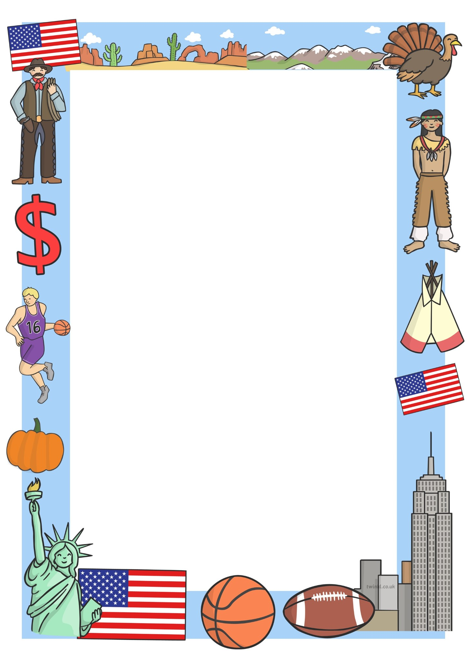1

**Pendoylan Church in Wales Primary School**

**Summer Term 2019**

Dear Parents,

I hope you had a good Easter break and the children are refreshed and ready to embark on the final term of this academic year. The year just seems to be flying by which links us into our new topic for the term, ‘Go West.’ The following is an overview of what we aim to cover in each of the six Areas of Learning and Experience.

**Language, Literacy and Communication**

**Oracy**

Here the children will explain information and ideas using relevant vocabulary and organise what they say so that listeners can understand. They will contribute to group discussions and talk to complete a group task.

**Writing**

During the term, the children will be writing for different purposes choosing words for interest. They will learn the techniques of writing adverts and use a range of different reading materials such as newspapers, brochures, leaflets and advertisements to support the development of use of language, layout and presentation techniques. Comparisons will be made between different types of adverts. Pupils will choose a location of interest and make a simple advert and leaflet about the resort using ICT.

The children will also be involved in writing postcards and play scripts.

There will be a focus on Persuasive writing - why the USA is the best holiday destination ever!

Creative Writing will be developed from our Write Stuff books and from the topic.

**Handwriting:**

Here we will again focus on ensuring that letters are correctly formed using a cursive approach and encourage children to join up their writing fully.

**Reading**

Skills to be developed will include using a range of strategies to make meaning from words and sentences. Using visual clues eg illustrations, diagrams, to enhance understanding and skimming to gain an overview of a text. The children will also be developing their ability to look for specific information in texts using contents, indexes, glossaries, dictionaries and locate information on web pages.

**Spelling:**

Your child will continue to have a new list of words to learn to spell every Friday. Please could you help your child practise their spellings on the practice sheet provided. Spelling tests will continue to be carried out every Friday.

During the course of the term, the children will be working on:

**Humanities**

During the term, we will be learning about

**Science and Technology**

Later on in the term, we will be taking the children, along with Class 4, on a trip to look at animal/insect habitats via pond studies. A possible option is The Botanical Gardens in Carmarthen.

If you have been on holiday to the U.S.A then II would be very grateful if you could send into school, some photographs of your child on holiday there. (All photographs will be returned at the end of term.) These photographs will be used in our Geography lessons and on our classroom display board.

P.E will continue to be on a Wednesday and Friday afternoons. Children will need to bring their P.E kit and trainers for each session as we will be outside. (Weather permitting.)

The National Reading and Mathematics tests will be held in May. It is important that your child unless unwell, is in school on these days. The timetable for Year 3 is as follows:-

Wednesday 8th May - Reasoning Test (Mathematics)

Thursday 9th May - Reading Test.

May – Procedural Mathematics Test (new test now sat online)

The children have had lots of practice at test style questions in order to make the sitting of the tests as stress free as possible. If you have any queries, then please feel free to contact school.

As you can see, it will be another action packed and fun term!

Yours Sincerely,

Mrs E.N Harris



**Mathematics and Numeracy**

Skills to be developed this term:-

To add multiples of 10 and 100 to 3-digit numbers and subtract multiples of 10 and 100 from 3-digit numbers. To multiply multiples of 10 by 1-digit numbers.

Begin to understand equivalence by placing fractions on a number line. Add and subtract fractions with the same denominator to make one.

To divide with remainders.

To use known tables and place value to multiply 2-digit by 1-digit numbers with the grid method.

To interpret and complete pictograms where 1 symbol represents 2 items and to ask and answer questions about the data represented in pictograms and block graphs.

To collect and organise data in tally charts. To Interpret and complete block graphs where 1 block represents 2 items and interpret and present data in bar charts where 1 division represents 2 units , 100 units etc

|  |
| --- |
|  |
| To begin to say the time ten minutes, or twenty minutes, later or earlier  To use vocabulary such as morning, afternoon, noon, and midnight; also am and pm times and 12 hour clocks  To write and tell the time to the nearest minute using analogue and digital clocks.  To use 24 hour clocks. |
| To develop an understanding of equivalence in fractions; 1/2s, 1/3s, 1/4s, 1/5s, 1/6s, 1/8s, 1/10s and find fractions of amounts and relate to division and multiplication  Understand tenths (1/10s) as fractions and place them on a line.  **Science**  The children will be learning about different habitats such as deserts, mountains, rivers, seas, ponds, rainforest etc.  They will also be investigating climate and comparing the different climates in the USA to that in the UK.  Food chains will also be researched.  Investigations will be planned and carried out during the term and the children will also investigate magnetism.  **Technology**  To use J2E5 to create at least two features for an information text- headings, labelled diagrams, pictures, fact boxes and animation features.  Word Online  Choose a location of interest and make simple adverts and leaflets about the resort. Use ICT to create. Include images downloaded from the internet to illustrate. Maps and facts/data from previous research about the location can also be used.  Solving Problems and Thinking Critically  To understand what a database is and pupils will create their own databases. |



**Digital Creativity and Innovation**

To look at a previously made PowerPoint and discuss how it communicates information. Show how to add text to a slide or import an image.

Look at how to change background colour etc. Children to create their own PowerPoints relating to the topic.

**Humanities**

Linked to the topic, we will be finding out about the Founding Fathers and the American flag, The Pilgrim Fathers, The Native Americans and famous US landmarks.

This topic will focus greatly on geographical skills which include:-

Map of the World- Identifying the 7 continents (Antartica, North and South America, Asia, Africa, Europe and Australia/Oceania).

Investigating the 4 oceans (Indian, Pacific, Atlantic and Arctic)

Compass points and co-ordinates

Lines of Longitude and latitude, the equator

Locating the USA on a map.

Comparing the UK and the US. - Investigating population sizes, number and names of states, capital cities, distance from the UK, climate, food, languages spoken etc.

Famous attractions/ landmarks in the US EG Disneyland, The Empire State Building, The Statue of Liberty, The Grand Canyon, Arizona Desert, The White House, Hollywood.

Researching places to visit in the US for holidays. Looking at geographical features of different areas.

What to pack for holidays in different states.

**P.E**

P.E will continue to be on a Wednesday and Friday afternoons. Children will need to bring their P.E kit and trainers for each session as we will be outside. (Weather permitting.)

Learning team games - **Rounders** -rules and how to play it.

**Tennis**

Skills: Hit Ups, hand return, bouncing a ball and hitting the ball to a partner

Volley, keeping a rally going.



**R.E**

Understanding Christianity SOW

Places and Symbols

Creation and Fall

The church year eg Ascension Day

Values :- Perseverance and Courage

**Expressive Arts**

**Art/DT**

Making dream catchers

Making teepees and Indian Art

Georgia O’Keeffe (American artist known for her paintings of enlarged flowers, New York skyscrapers and New Mexico landscapes. Recognised as the ‘Mother of American Modernism.’)

**Music/Drama**

Looking at musical notes –names and values

Looking at note sounds using chime bars. Investigating sound producing potential of percussion instruments.

Investigating rhythms

Using voice in rhyme, song and rap.

If you have visited the USA and have any photographs of famous landmarks then we would be very grateful if we could borrow any for our classroom display.

Looking forward to an action packed term!

Thank you for your support.

Kind Regards

Mrs E. Harris



